**Trending 20**

**A Mini-Project Report**

**Under**

**IMPLEMENTATION OF TECHNOLOGY**

***Submitted by***

**Rishabh Jain,**

**Akshat Bansal and**

**Anmol Bagati**

***Under The Guidance Of***

**PROF . RATNESH CHATURVEDI**

***in partial fulfillment for the award of the degree***

***of***

**MBA TECH**

**IN COMPUTERS**



**at**

**nmIMS’S mUKESH PATEL SCHOOL OF TECHNOLOGY MANAGEMENT & eNGINEERING, mUMBAI**

**APRIL, 2016**

***CERTIFICATE***

This is to certify that the project entitled **Trending 20** is the bonafide work carried out by **Rishabh Jain, Akshat Bansal and Anmol Bagati** of MBA.Tech (Computer Engineering), MPSTME (NMIMS), Mumbai, during the fourth semester of the academic year 2015-2016, in fulfillment of the requirements for the award of the Degree of MBA Tech as per the norms prescribed by NMIMS. The project work has been assessed and found to be satisfactory.

___________________

Ratnesh Chaturvedi

Internal Mentor

_______________________ ___________________

Examiner 1 Examiner 2

________________________

Dean

Dr. Sharad Y .Mhaiskar

***DECLARATION***

We, **Rishabh Jain, Akshat Bansal and Anmol Bagati** of MBA.Tech (Computer Engineering), semester- IV, understand that plagiarism is defined as anyone or combination of the following:

1. Un-credited verbatim copying of individual sentences, paragraphs or illustration (such as graphs, diagrams, etc.) from any source, published or unpublished, including the internet.

2. Un-credited improper paraphrasing of pages paragraphs (changing a few words phrases, or rearranging the original sentence order)

3. Credited verbatim copying of a major portion of a paper (or thesis chapter) without clear delineation of who did wrote what.

4. We have made sure that all the ideas, expressions, graphs, diagrams, etc., that are not a result of our work, are properly credited. Long phrases or sentences that had to be used verbatim from published literature have been clearly identified using quotation marks.

5. We affirm that no portion of my work can be considered as plagiarism and we take full responsibility if such a complaint occurs. We understand fully well that the guide of the seminar/ seminar report may not be in a position to check for the possibility of such incidences of plagiarism in this body of work.

Signature of the Students:

___________ ____________ ___________

Name: ___________ ____________ ___________

Roll No. ___________ ____________ ___________

Place: Mumbai

Date: April 2016

***ACKNOWLEDEMENT***

We have taken efforts in this project. However, it would not have been possible without the kind support and help of many individuals. We would like to extend our sincere thanks to all of them.

We are highly indebted to Prof. Ratnesh Chaturvedi for his guidance and constant supervision as well as for providing necessary information regarding the project & also for his support in completing the project.

We would like to express our gratitude towards our parents for their kind co-operation and encouragement which helped us in completion of this project.

Our thanks and appreciations also go to our batch mates in developing the project and people who have willingly helped us out with their abilities.

**Abbreviations**

|  |  |
| --- | --- |
| **Abbreviation** | **Description** |
| ADB | Android Debugging Bridge |
| ADT | Android Development Tools |
| Android SDK | Android Software Development Kit |
| ART | Android Runtime |
| CPU | Central Processing Unit |
| CR | Class Representative |
| GPU | Graphic Processing Unit |
| HoD | Head of Department |
| IPS | In-Plane Switching |
| LCD | Liquid Crystal Display |
| RAM | Random Access Memory |
| SQL | Structured Query Language |
| SR | Student Representative |
| XML | Extensible Markup Language |

***ABSTRACT***

Modern hand held devices such as smart phones and PDAs have become increasingly powerful in recent years. Dramatic breakthroughs in processing power along with the number of extra features included in these devices have opened the doors to a wide range of commercial possibilities. In particular, most cell phones regularly include cameras, processors comparable to PCs from only a few years ago, and internet access. However, even with all these added abilities, there are few applications that allow much passing of the environmental information and location based services.

Suppose you have to search for the best restaurant or cafes or games or anything, Trending 20 is the app where you come. The prime objective of TRENDING 20 is to create a full fledged Android application which helps you find out the best of any category you could think of. These ratings are based on user given feedbacks. The users can login into the app by registering or using ‘Sign in with Google or facebook’ option.

The Project is developed in Java Programming Language by using the Android Studio Integrated Development Environment (IDE). We used the Android Software Development Kit (SDK) which includes a variety of custom tools that help us develop mobile applications on the Android platform. The most important of these are the Android Emulator, HXAM Accelerator and the Android Development Tools (ADT) packages for Android Studio.

**Table of contents**

**CHAPTER NO. TITLE**

List of figures

Abbreviations

Abstract

1. INTRODUCTION

1.1 Hardware Specification

1.2 Software Specification

2. ANALYSIS & DESIGN

3. METHODS IMPLEMENTED

4.

5. CONCLUSION & FUTURE SCOPE

REFERENCES

***LIST OF FIGURES***

**CHAPTER NO. TITLE**

1. INTRODUCTION

Fig 1.1 - Android Architecture Diagram

2. ANALYSIS AND DESIGN

Fig 1 - Welcome Screen

Fig 2 - Login Screen

Fig 3 - Category Page

Fig 4 - Search Page

Fig 5 - Final Page ( Search outcome )

***INTRODUCTION***

**Introduction to Android:**

Android is an open source and Linux-based operating system for mobile devices such as smart phones and tablet computers. Android was developed by the Open Handset Alliance, led by Google, and other companies.

Android provides a rich application framework that allows you to build innovative apps and games for mobile devices in a Java language environment.

Android Architecture:

Android operating system is a stack of software components which is roughly divided into five sections and four main layers as shown below in the architecture diagram.

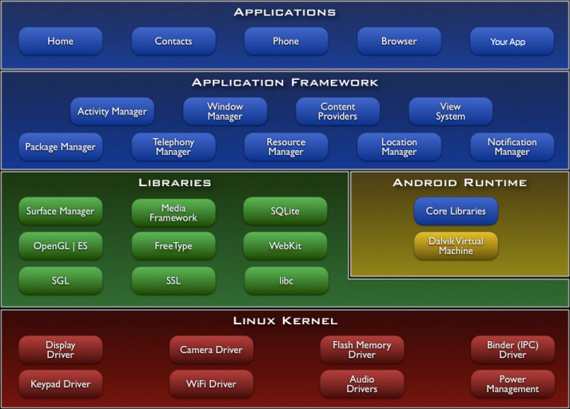

Fig 1.1

Android gives you a world-class platform for creating apps and games for Android users everywhere, as well as an open marketplace for distributing to them instantly. Android operating system is a stack of software components which is roughly divided into five sections and four main layers as shown below in the architecture diagram.

You will find all the Android application at the top layer. You will write your application to be installed on this layer only. Examples of such applications are Contacts Books, Browser, Games etc. These comprise both the native applications provided with the particular Android implementation (for example web browser and email applications) and the third party applications installed by the user after purchasing the device. Applications created by third party users or developers will be installed here.

**Introduction to Application:**

* Cant decide what to do?
* Trending 20 is the place where you come.
* You choose from categories like restaurants, cafes, clubs etc.
* User can rate their experiences .
* The top 20 from the chosen categories keeps changing according to the user ratings.

Hardware Specification

Trending 20 is not a hardware intensive application, thus requires very basic level of hardware, as its application ranges across all devices, low end to high end, phones to tablets. Thus, the following are the minimum hardware specifications required to run the application:

* Processor:
  + Quad-core 1.2 GHz
  + PowerVR SGX 540 GPU.
* Memory:
  + 768 MB RAM
  + 1 GB of Flash Memory
  + Micro-SD card slot (Optional)
* Screen:
  + 3.5-inch LCD display
  + Capacitive or Resistive touch

During Development of the application, a Nexux 5X was used to develop and test the application.

Trending 20 is designed to work on Android 4.0, Ice Cream Sandwich and above.

Apart from Android 4.0 and above, the application, like most android applications can run on the following Operating Systems:

* Blackberry OS 11
* Sailfish OS
* Chrome OS
* Color OS
* INUI OS
* YUN OS
* Nokia X mobile Platform

Some of these are based on android, while some (Bbos 11, Sailfish OS) are made compatible to run android applications. Following is the list of Android versions on which BoozeHound has been tested:

* Android 4.0 (Ice Cream Sandwich)
* Android 4.2 (Jellybean)
* Android 4.3 (Jellybean)
* Android 4.4 (KitKat)
* Android 5.0 (Lollipop)
* Android 5.0.2 (Lollipop)
* Android 5.1 (Lollipop)

This gives the application a broad platform, as these operating systems are in majority of smart phones being used by prospective users.

# Review of Literature

A literature review is a text of a scholarly paper, which includes the current knowledge including substantive findings, as well as theoretical and methodological contributions to a particular topic. Most often associated with academic-oriented literature, such as a thesis, dissertation or a peer-reviewed journal article, a literature review usually precedes the methodology and results section although this is not always the case. Literature reviews are also common in a research proposal or prospectus. Its main goals are to situate the current study within the body of literature and to provide context for the particular reader. Literature reviews are a basis for research in nearly every academic field.

**Java:**

Java is a set of several computer software and specifications developed by Sun. Microsystems, later acquired by Oracle Corporation, that provides a system for developing application software and deploying it in a cross-platform computing environment. Java is used in a wide variety of computing platforms from embedded devices and mobile phones to enterprise servers and supercomputers. While less common, Java applets run in secure, sandboxed environments to provide many features of native applications and can be embedded in HTML pages.

Writing in the Java programming language is the primary way to produce code that will be deployed as byte code in a Java Virtual Machine (JVM); byte code compilers are also available for other languages, including Ada, JavaScript, Python, and Ruby. In addition, several languages have been designed to run natively on the JVM, including Scala, Clojure and Groovy. Java syntax borrows heavily from C and C++, but object-oriented features are modeled after Smalltalk and Objective-C.Java eschews certain low-level constructs such as pointers and has a very simple memory model where every object is allocated on the heap and all variables of object types are references. Memory management is handled through integrated automatic garbage collection performed by the JVM.

***ANALYSIS & DESIGN***

During the conception of the application, the requirements were mapped out first. This included analyzing the need of this application, its features and figuring out a list of functions it would perform during operation. This largely consisted of the analysis.

After performing a complete analysis, the design of the application was pursued. Abnegate was designed using material design. Material design is a comprehensive guide for visual, motion, and interaction design across platforms and devices.

## Features:

* User-Friendly app Light-Weight

**Fig 1: Wellcome screen**

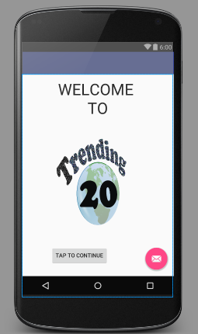

**Fig 2: Login Screen**

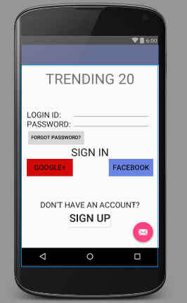

**Fig 3: Category Page**

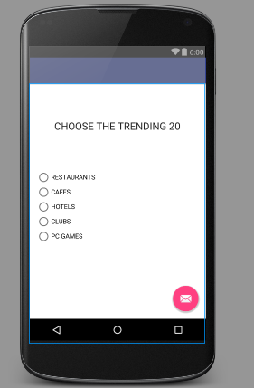

**Fig 4: Search page**

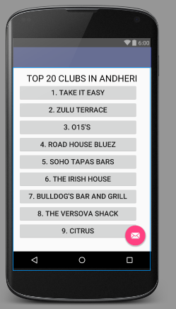

**Fig 5: Final Page**

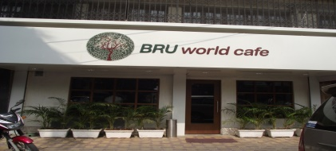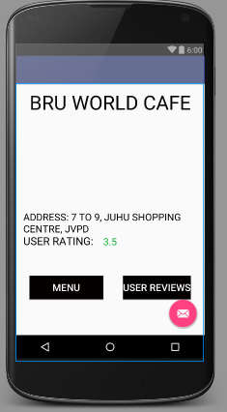

***METHODS IMPLEMENTED***

**Introduction to Android Studio:**

Android Studio is the official IDE for Android application development, based on IntelliJ IDEA. On top of the capabilities you expect from IntelliJ, Android Studio offers:

Flexible Gradle-based build system.

Build variants and multipleapk file generation.

Code templates to help you build common app features.

Rich layout editor with support for drag and drop theme editing lint tools to catch performance, usability, version compatibility, and other problems.

ProGuard and app-signing capabilities.

Built-in support for Google Cloud Platform, making it easy to integrate Google Cloud.

Messaging and App Engine.

**SQL Lite Database:**

SQLiteDatabase has methods to create, delete, execute SQL commands, and perform other common database management tasks.

See the Notepad sample application in the SDK for an example of creating and managing a database.

Database names must be unique within an application, not across all applications

1.We have implemented adding of Database on the Login and Register Activities.

2.We have linked the Buttons to Activites using intent.

3.We have inserted several Text Fields and Text Views in many Activities.

4.We have linked the SQLite Database to the Login and Register Activities in our application.

***CONCLUSION & FUTURE SCOPE***

The prime objective of TRENDING 20 is to create a full fledged Android application which helps you find out the best of any category you could think of.

The Project is developed in Java Programming Language by using the Android Studio Integrated Development Environment (IDE). We used the Android Software Development Kit (SDK) which includes a variety of custom tools that help us develop mobile applications on the Android platform.

***REFERENCES***

1. [www.youtube.com](http://www.youtube.com)
2. developer.android.com
3. [www.google.com](http://www.google.com)